GP2: PARTS B - E

**Team: CS_GROUP 03**

**SRNs: 19027747, 19009987, 19028989, 19000687, 19068430**

**Use Case Diagram**

**Use Case Description 1**

**Use Case**:Cancel a membership

**Actors**: Cinema Member

**Goal**: To cancel a current cinema members membership.

**Precondition**: Cinema Member is logged into the system and currently has an existing membership.

**Summary**: Member selects to end their membership. System shows confirmation box, and the member confirms that they want to end their membership. The system updates the membership status of the account so that membership deals are no longer shown.

**Related use cases**: None

**Steps** - **main flow**:

|  |  |
| --- | --- |
| **Actor action:** | **System Response:** |
| 1. Cinema member selects to cancel their membership |  |
|  | 2. System shows a box asking the member if they’re sure they want to cancel their membership. |
| 3. Cinema member selects ‘confirm’ button to confirm their choice. |  |
|  | 4. The system updates the membership status of their account and provides confirmation that they’re no longer a member. |
|  |  |

**Steps** - **exceptional flow**.

|  |  |
| --- | --- |
| **Actor action:** | **System Response:** |
| **Exceptional Flow 1:** |  |
| (Any step before 4.)  Cinema member selects to cancel the process. | System returns to home screen.  Exit from use case. |

**Use Case Description 2**

**Use Case**:Make a booking

**Actors**: Cinema goer, Credit Card Agency

**Goal**: To allow a cinema goer/member to book tickets for a performance.

**Precondition**: Cinema goer is logged in, either as a guest or an account holder.

**Summary**: Cinema goer selects the film they want to book for and provides the number of seats they require. The system finds performances that match the criteria and displays them. Cinema goer selects a performance, and the system calculates the price of the booking. The cinema goer then pays for the bookings and confirmation is sent to them.

**Related use cases**: Find Membership

**Steps** - **main flow**:

|  |  |
| --- | --- |
| **Actor action:** | **System Response:** |
| 1. Cinema goer selects the film they want to make a booking for. |  |
|  | 2. The system updates the screen to ask the user what cinema they would like to view the film at. |
| 3. Cinema goer selects which cinema to view the film at. |  |
|  | 4. System finds and displays performance dates for the chosen film. |
| 5. Cinema goer selects the performance date and time they want to attend. |  |
|  | 6. System checks the number of available seats for the chosen performance and restricts the input (for the number of seats) to only allow a selection of seats up to the amount remaining. |
| 7. Cinema goer uses the drop-box to select the number of seats they want. User selects to proceed with booking. |  |
| 8. Find Membership  (Note: Checks if the cinema goer currently logged in is a member) |  |
|  | 9. The system calculates the price of the booking and if the cinema goer is a member applies the necessary discounts. System displays the final booking screen with the price, details of the chosen performance along with the stored name and email of the customer. |
| 10. Cinema goer selects to confirm their booking and pay |  |
|  | 11. System displays payment screen |
| 12. Cinema goer fills in the details for the payment. |  |
| 13. Confirm payment and booking details. |  |
|  | 14. Ask Credit Card Agency to validate payment |
|  | 15. System saves the booking. A confirmation email is sent to the cinema goer with a virtual ticket and the confirmation of their booking is displayed. |
|  | 16. The system updates the number of available seats for the performance the cinema goer has booked for. |

**Steps** - **exceptional flow**.

|  |  |
| --- | --- |
| **Actor action:** | **System Response:** |
| **Exceptional Flow 1:** |  |
| (Any step before 13)  Cinema goer cancels booking process. | The system displays the home screen.  Exit from use case |
| **Exceptional Flow 2:** |  |
|  | 9. If user is logged in as a guest, display an additional box to enter a name and email address to send the virtual ticket to. |
| **Exceptional Flow 3:** |  |
|  | 14. [Credit card validation fails]  Display message. Go to step 12. |
| **Exceptional Flow 4:** |  |
| (Any step before 13)  Cinema goer selects to go back to change entered details. | The system returns to the previous actor action. |
| **Exceptional Flow 5:** |  |
|  | 12. [Cinema goer account has saved payment details]  System fills in the details of the payment with the cinema goers saved payment details.  Go to step 13. |

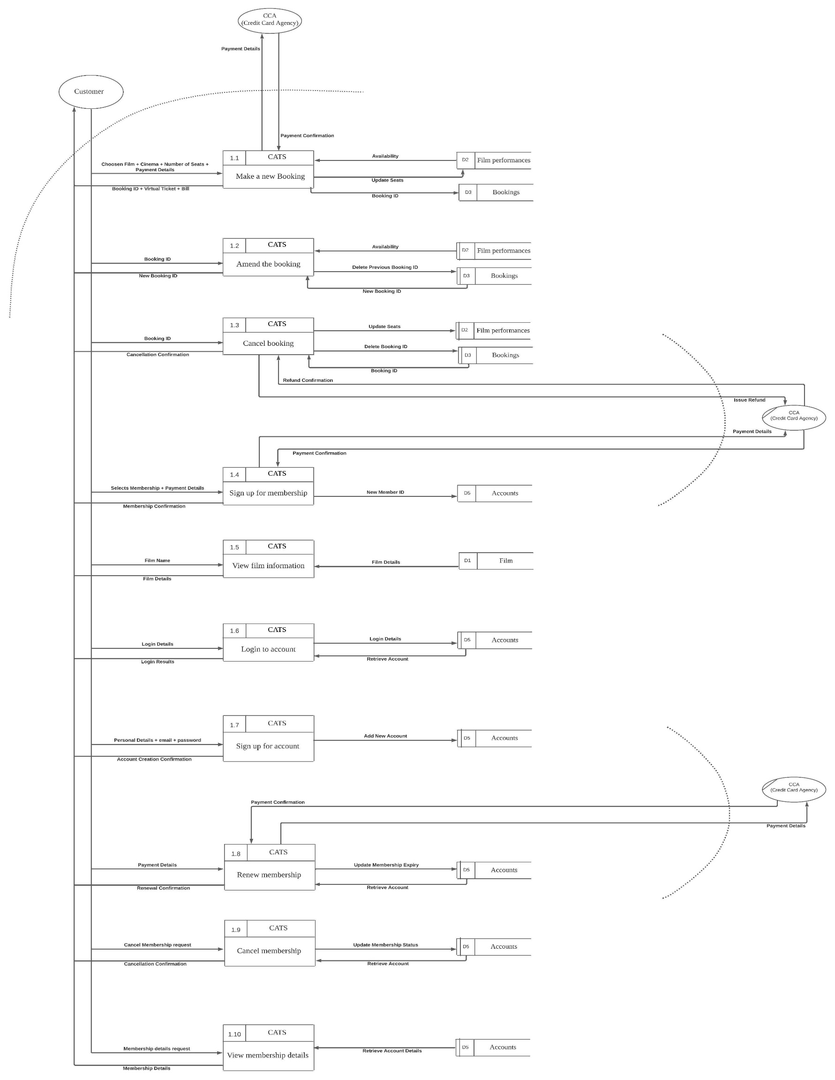

**Level 2 Data Flow Diagram**

**Storyboard 1: Main Pre-Login Screen**

**Storyboard 2: Main Post-Login Screen**

**Storyboard 3: Main Screen (Customer)**

**Storyboard 4: One Customer Process Screen**

